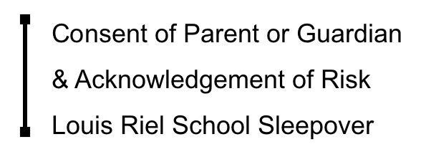

Please Read Carefully

Student Name: ____________________________________________________________________

My child will be given the opportunity to participate in the following activity:
GATE Grade 4 Sleepover
School: Louis Riel School
Purpose of Trip: Curriculum – Alberta: The Land, Histories & Stories
Destination: Louis Riel School
Dates: April 16-17
Teachers in Charge: Mr deBoer & Mrs Armitage

The Board will make commercially reasonable efforts to ascertain that:
- Supervisors and staff are fully trained and qualified
- Students who undertake the program or activities will be adequately supervised
- Location meet the applicable health and safety standards
- Equipment used in the activities has been inspected and deemed to be appropriate, safe and well maintained

Consent & Acknowledgement of Risk
The activities that the students will participate will be no different than the daily activities that a regular day of school would involve.
Activity | Risk/Hazard (Cause of Injury)
Entire Trip  (gym games, moving throughout the building) | -Slips and falls  -Getting Separated from the group  -Pre-existing medical conditions
Eating | -Choking  -Allergies

Terms and Conditions:
- I freely and voluntarily assume the risks and hazards in the nature of the activity and understand that my child, as a participant, may suffer personal and potentially serious injury, illness or death due to unforeseeable or fortuitous event.
- My child will has been informed the he/she is to abide by the rules and regulations including directions and instructions from the CBE teacher. This shall include his/her participation in all introductory sessions and meeting all prerequisites prior to his/her participation in the activity.
- In the event that my child fails to abide by the rules and regulations imposed on the students while participating in the activity, that the CBE Teachers may determine that he/she not participate in the program or activity and may require the parents to pick-up their child.
- I acknowledge that it is my responsibility to advise the CBE of any medical or health concerns of my child which may affect his/her participation in the stated program.
- Consent that the CBE may secure such medical advice and services as the CBE, in its sole discretion, may deem necessary for my child’s health and safety, and I shall be financially responsible for such advice and services.
- Based upon my understanding of the activity and the hazards identified above, I give my child permission to participate in this activity.
- I have read and understood the information package provided by the school about this activity and I have discussed the risk and expectations of the activity with my child and have confidence that my child has understood them.

Date: ___________________

Student Name: __________________________________________________________

Parent /Guardian Name (print) :______________________________________________

Parent /Guardian Signature: ________________________________________________

VOLUNTEER!?!?
If you are able to VOLUNTEER please complete the following portion:

_____ I have a current Criminal Record Check and am cleared to volunteer for school events.

_____ I am a risk taker and would love to sleepover for the whole night!

_____ I would love to be the breakfast team leader and organize the feeding of 47 people Friday morning!

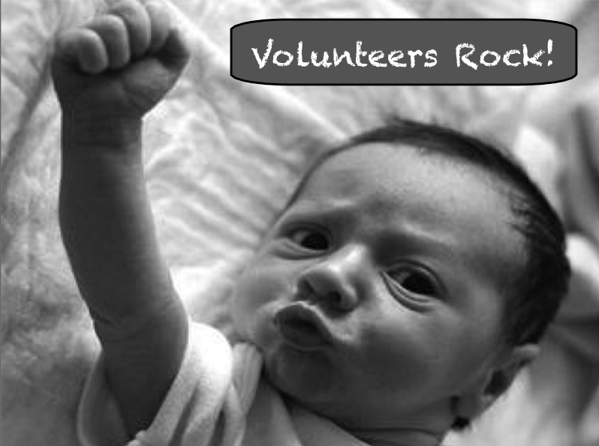
_____ I would love to join the Breakfast Team and help out with the preparation of breakfast on Friday morning!

